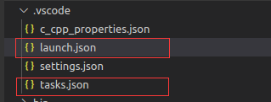

Vscode的启动配置在launch.json中配置，我们可以点击如下按钮添加默认配置

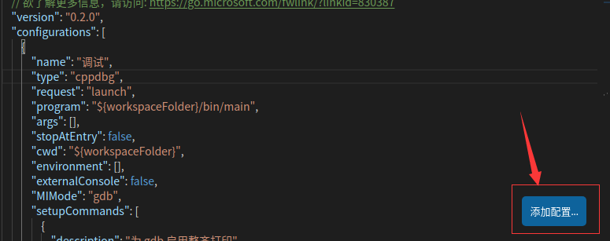

Launch.json各个配置项介绍

        {

            // 启动的显示名称

            "name": "调试",

            "type": "cppdbg",

            "request": "launch",

            // 要启动的可执行程序路径

            "program": "${workspaceFolder}/bin/main",

            // 启动时需要的参数

            "args": [],

            "stopAtEntry": false,

            "cwd": "${workspaceFolder}",

            "environment": [],

            // 调试时是否显示控制台窗口

            "externalConsole": false,

            // 调试器

            "MIMode": "gdb",

            "setupCommands": [

                {

                    "description": "为 gdb 启用整齐打印",

                    "text": "-enable-pretty-printing",

                    "ignoreFailures": true

                }

            ],

            // 启动前需要执行的任务

            "preLaunchTask": "debug"

        }

任务配置文件tasks.json

{

    "version": "2.0.0",

    "tasks": [

        {

            "label": "debug",

            // 任务的类型

            "type": "shell",

            // 执行的命令

            "command": "cmake -DCMAKE_BUILD_TYPE=Debug .; make;"

        },

        {

            "label": "release",

            "type": "shell",

            "command": "cmake -DCMAKE_BUILD_TYPE=Release .; make;"

        }

    ]

}